Note:For example 192.168.1.0/24 uses,because its class c it uses a ‘/24’ prefix length.
Maximum hosts per network(All usable addresses)=2ⁿ-2(n=number of host bits)
Note:Network address is also refered as Network ID.
First usable and last usable addresses,for example for 10.0.0.0/8 are 10.0.0.1/8 and 10.255.255.254/8 correspondingly.
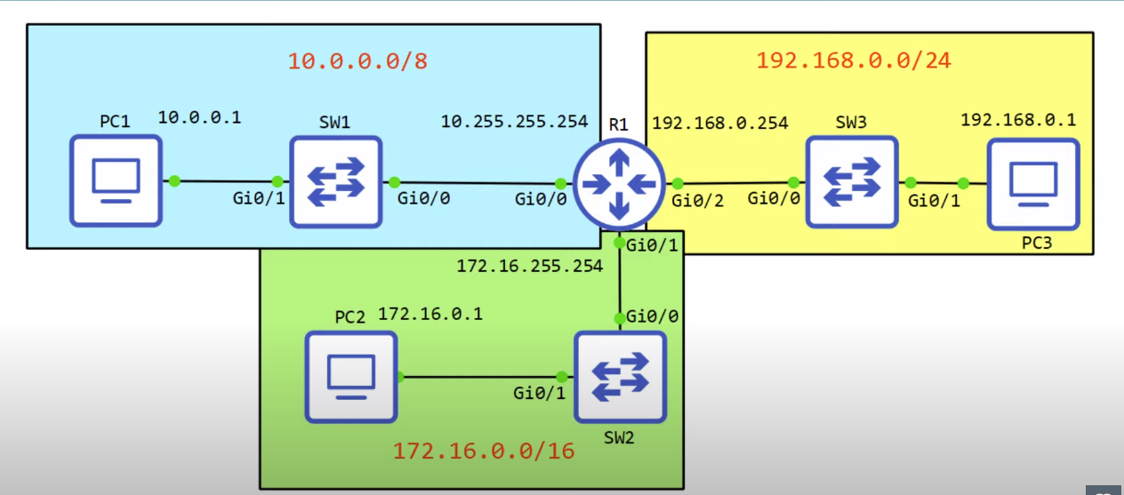

Three small networks connected to R1.
Note: Each of three interfaces of R1 have last usable address of each small network(for example Gi0/0 interface has 10.255.255.254 address,which is the last usable address in 10.0.0.0/8 network)

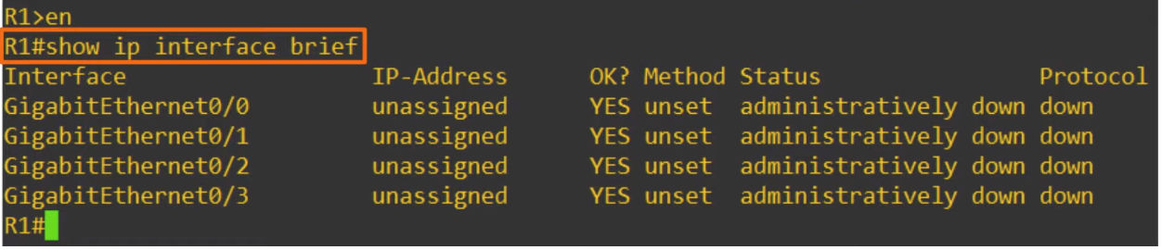
‘shop ip interface brief’ command to confirm the status of each interface on the device,as well as their IP-addresses.

· Interface column displays network’s interfaces on the device.
· OK column is possibly a legacy feature,basically it says whether or not the IP address is valid or not,on modern devices device won’t let you assign invalid IP addresses,so you should never see NO in this column.The interfaces currently have no addreses assigned,and as we can see it is considered a valid state.
·Method indicates the method by which the interface was assigned an IP address.Currently the status is unset.
· Basically we can consider Status column as Layer 1 status of the interface if the interface is enabled,there is a cable connected,and the other end of the cable is connected to another device is properly connected to another device we should see ‘up’ here.However here it displays ‘administratively down’,this means that the interface has disabled with ‘shutdown’ command.
Note:This is the default status of cisco router interfaces.
Note: Cisco switch interfaces are not administratively down by default,they will either be up if they are connected to another device ,or down,if they are not connected.
Note: Even though G0/0,G0/1,G0/2 interfaces are connected to switches,the interfaces remain administratively down because interfaces has been disabled with shutdown.
Note:While the status column referred to Layer 1 status of the interface,this is the Layer 2 status of the interface.Because the interfaces are down at Layer 1,Layer2 can’t operate,so all of this interfaces are down at Layer 2.
Note:Status refers to Layer 1 status,for example,is the interface shutdown,is there cable attached etc..
Note:Protocol column refers to Layer 2 status,for example is ethernet functioning properly between this device and the device it’s connected to.

Configuring the router
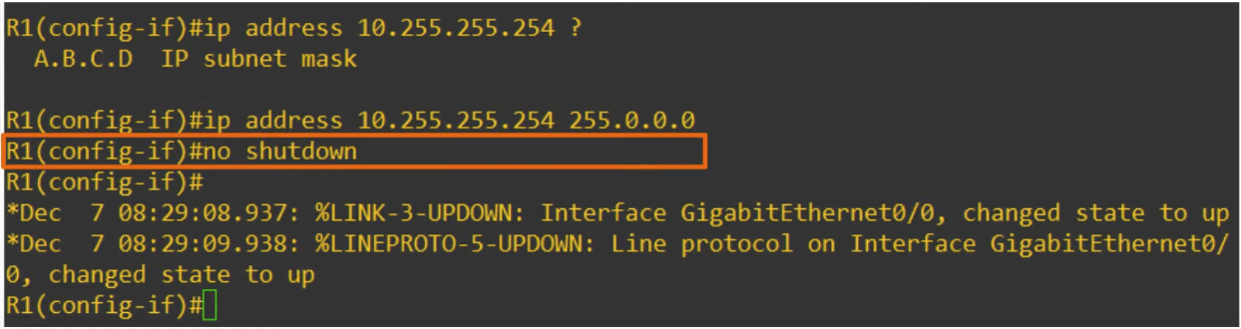
First we enter global configuration mode(‘conf t’ command ).And then to configure interface itself we have to enter interface configuration mode(‘interface <interface_name>’ command,for example interface gigabitethernet0/0 or for short g0/0,and it will bring us to configuration mode for gigabitethernet0/0).When we are in interface configuration mode When we are in interface configuration mode,we can set the IP address,that is done with command ‘ip address <IP address>‘.
‘no shutdown’ command is used to enable the interface.Cisco routers interfaces have the ‘shutdown’ command applied to them by default,to cancel them we type ‘no shutdown’ command.Then we get two messages.First says that gigiabitethernet0/0 changed state to up,it refers to the physical layer status of the interface(‘Status’ column).Second message is ‘Line protocol on Interface gigabitethernet0/0 changed state to up’ ,this is the Layer 2 status of the interface,(‘Protocol’ column).
Note: ip address command also has ‘subnet mask’ (Also known as netmask) option.If we don’t enter subnet mask system will typically use defualt subnet masks based on the class of IP address(Answer from chatgpt).
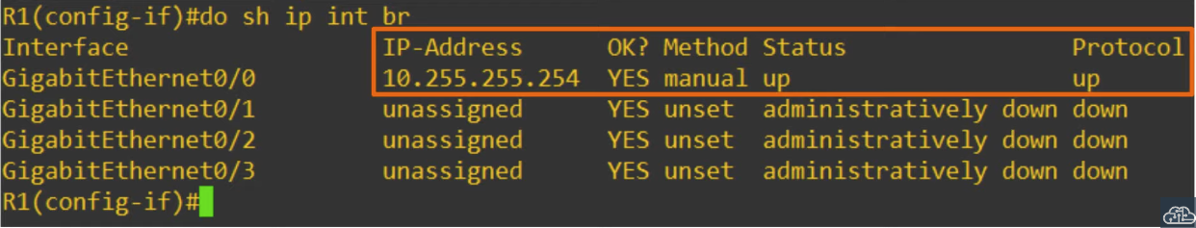
After all the steps of configuration.(do is written to execute privileged exec mode command in interface configuration mode)
Note:When configuring other interfaces we dont have to type ‘exit’ command to return to global config mode.We just type ‘interface <another interface_name>’.
Note:Method=manual means that IP addresses are configured manually.
Note: Router’s interfaces also have MAC address.
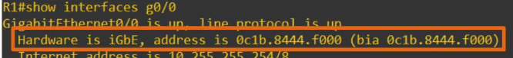
Part of the output of ‘show interfaces’ command
Note:0c1b.8444.f000 is the MAC address of g0/0 interface.Bia MAC address is the ‘burned in address’,which is the actual physical address of the interface,however we can configure a different MAC address in the CLI,although usually we don’t configure MAC address.
Configuring interface descirption
To configure interface description we use ‘description <description>’ command.We can view descriptions with ‘show interfaces description’ command.

‘end’ commmand
We can use ‘end’ command to switch from interface configuration mode to priveleged exact mode,instead of writing ‘exit’ command twice to exit from interface config mode and after exit from global config mode.

